Servo motor calibration

When developing the first version of the robot, I encountered similar issues. The primary reason the robot is not walking properly is that the motors are not accurately reaching their set-point positions. For example, when commanded to move to 90 degrees, they only reach 70 degrees.
To resolve this issue, the motors need to be calibrated near the initial pose. This is because, near the initial pose, the motor response is approximately linear to the set-point, allowing for more precise motion angle response.

The initial pose is considered as in the following figure, where the leg is at a 90 degrees angle.

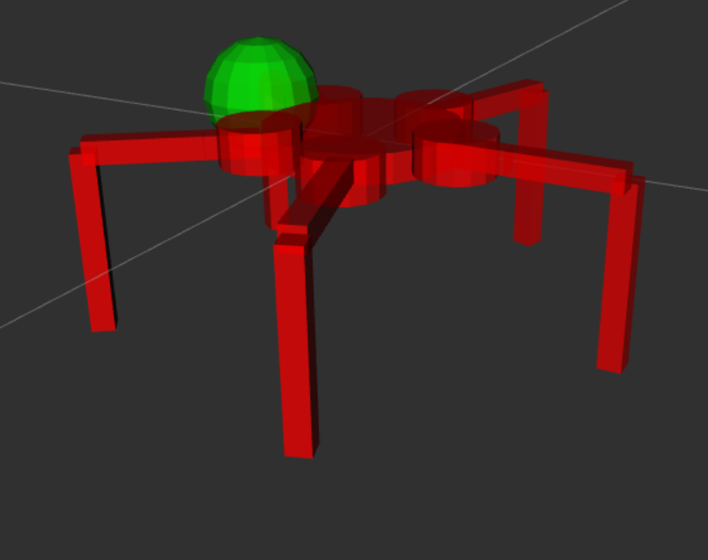

In this case, the robot looks like a table with 5 legs, all 5 legs are normal to the ground and the table base is parallel to the ground. Following figure shows up-down view for the robot in the initial configuration

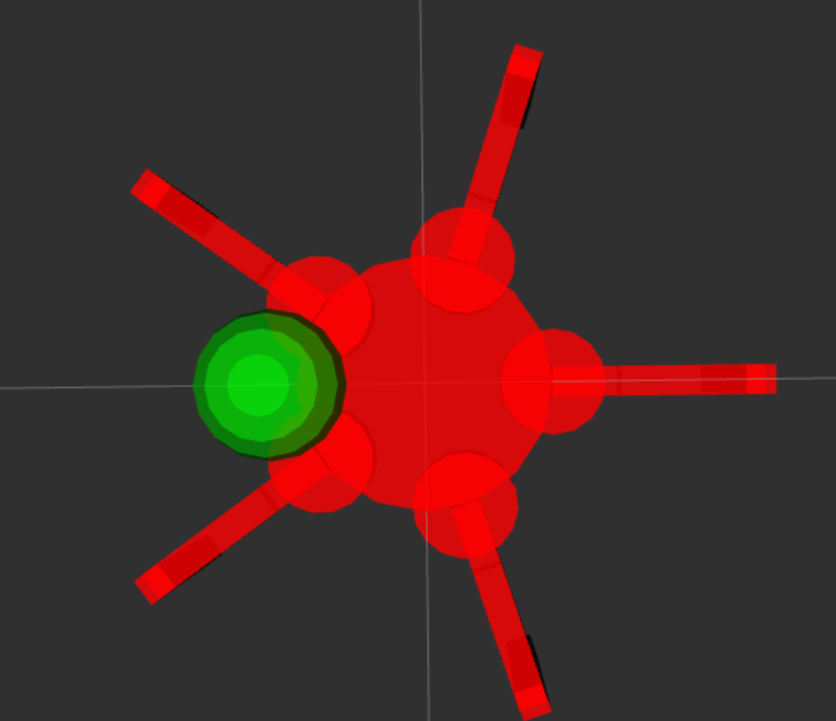

Calibration process:

A new branch is created under:

https://github.com/Modi1987/scorpion/tree/linearization_near_calibrated_coniguration

Download the code from this branch. Then, the calibration process begins with the GUI helper tool. Use the sliders in the GUI to move the robot into the aforementioned initial configuration (table configuration). Once the robot is in this position, record the actuator angles (from the sliders). These angles must then be inserted in the configuration YAML file under the parameter actuator_angles_at_initial_pose_degree, available in here:

https://github.com/Modi1987/scorpion/blob/linearization_near_calibrated_coniguration/penta_description/config/general_config.yaml#L43

After updating the yaml file, then do:

>> colcon build

Then run the robot again

Enjoy!

